java.util.Stack<E>

# 简单介绍

继承体系结构：

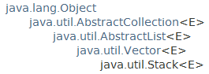

实现的接口：



The Stack class represents a **last-in-first-out (LIFO) stack of objects.** It extends class **Vector** with five operations **that allow a vector to be treated as a stack.** The usual **push and pop** operations are provided, as well as a method to peek at the top item on the stack, a method to test for **whether the stack is empty**, and a method to search the stack for an item and discover **how far it is from the top**.

**后入先出。**

When a stack is first created, it contains no items.

Deque接口比这个Stack更好：

A more complete and consistent set of LIFO stack operations is provided by the Deque interface and its implementations, which should be used in preference to this class. For example:

**Deque<Integer> stack = new ArrayDeque<Integer>();**

# 构造方法：



# 一般方法：

## 大部分方法都是继承Vector的，所以Vector有的，Stack都有。



## 特有的或覆盖的方法：

### push与pop方法

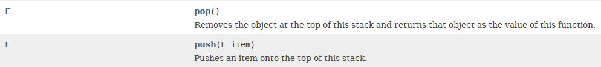

### search(Object o)



### peek()方法：



### empty()方法

